LectureSeek Interfaces and Architecture Diagram
Purpose. This document groups the existing LectureSeek high-level use cases under proposed interfaces, following the reference layout. Each interface contains only the high-level use cases from the current model.
Naming. Each proposed interface name uses the I + domain pattern. HL IDs and function names are reused from the current use-case model; the interface groupings are proposed for architecture documentation.

Interfaces:

IAccount | Account access and personal preferences
- HL-01 Manage accounts and preferences

ICatalog | Discover and search accessible lecture content
- HL-02 Find accessible lectures
- HL-18 Search concepts across lecture transcripts

ILecture | Lecture access, playback, ownership, and instructor library
- HL-03 Play and navigate a lecture
- HL-06 Add recorded lectures
- HL-07 Organize, share, and delete owned content
- HL-10 Manage the teaching library and revisions
- HL-17 Monitor resource processing
- HL-19 Navigate between slides and video moments

ITranscript | Transcript reading, editing, and preparation
- HL-04 Read and search lecture transcripts
- HL-08 Manage transcripts for owned lectures
- HL-11 Prepare lecture transcripts

ISlide | Slide analysis and topic/chapter structure
- HL-12 Prepare slides and lecture topics

ISummary | Official and personal lecture summaries
- HL-05 Review available summaries
- HL-13 Create and manage official summaries
- HL-20 Generate and manage personal summaries

IQuiz | Official and personal quizzes and assessment
- HL-14 Create and publish official quizzes
- HL-15 Configure mandatory quiz checkpoints
- HL-16 Review quiz outcomes and manage feedback
- HL-21 Generate and manage practice quizzes
- HL-22 Complete quizzes and review attempts

IStudy | Personal study resources, progress, exports, and images
- HL-23 Manage notes, bookmarks, and revision resources
- HL-24 Track personal study progress
- HL-25 Export personal study materials
- HL-30 Capture and edit study images

ITranslation | Translation of lecture learning materials
- HL-26 Translate learning materials

IDiscussion | Questions and answers about lecture content
- HL-27 Discuss lecture content

IDubbing | Dubbed audio requests and synchronized playback
- HL-28 Request and manage dubbed audio
- HL-29 Listen to synchronized lecture audio

IIssueReporting | Reporting platform and content issues
- HL-09 Report lecture or content problems

Architecture Diagram level 0:

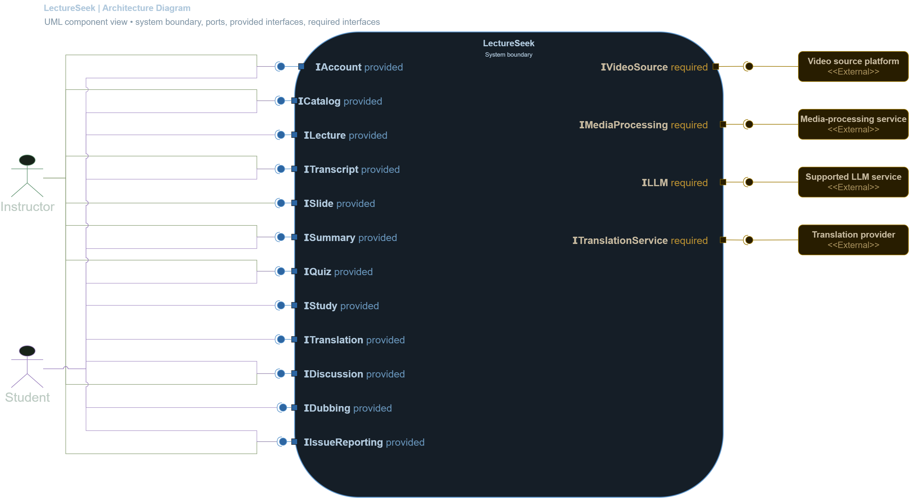

Source basis. High-level function names and IDs come from the current LectureSeek use-case model, which is traced to the SRS and User Stories. Interface groupings are proposed logical groupings; they do not claim that these interfaces are implemented in the repository.

Module Map:
Module | Scope | High-level use cases
Account & Access | Account identity, profile, preferences, and access context. | HL-01 Manage account and preferences
Lecture Library | Lecture intake, ownership, organization, publication, revisions, and processing status. | HL-06 Add recorded lectures  HL-07 Organize, share and delete content  HL-09 Monitor resource processing  HL-11 Manage teaching library and revisions  HL-17 Publish lecture resources
Transcript Processing | Preparation and maintenance of lecture transcripts and timed segments. | HL-08 Maintain owned transcript segments  HL-12 Prepare lecture transcripts
Slide & Visual Processing | Slide analysis and visual structure used to organize lecture content. | HL-13 Structure lecture slides and chapters (shared with Alignment & Chapters)
Alignment & Chapters | Connects timed transcript and slide evidence to lecture topics and chapters. | HL-13 Structure lecture slides and chapters (shared with Slide & Visual Processing)
Search & Playback | Lecture discovery, transcript access, cross-lecture search, synchronized playback and navigation. | HL-02 Find accessible lectures  HL-03 Watch and navigate lectures  HL-04 Read and search lecture transcripts  HL-19 Search concepts across lectures  HL-20 Navigate lecture slides
Learning Content | Official and personal summaries, quizzes, and quiz checkpoint configuration. | HL-05 Review available summaries  HL-14 Produce official summaries  HL-15 Create and publish official quizzes  HL-16 Configure mandatory quiz checkpoints  HL-21 Produce personal summaries  HL-22 Produce personal practice quizzes
Study & Assessment | Student assessment, results, study tools, progress, exports, and study images. | HL-18 Review student quiz performance  HL-25 Complete quiz assessments  HL-26 Review quiz results and attempts  HL-27 Manage notes and revision resources  HL-28 Track personal study progress  HL-29 Export personal study materials  HL-32 Capture and edit study images
Translation & Dubbing | Translated learning materials and dubbed lecture audio. | HL-23 Translate learning materials  HL-30 Request and manage dubbed audio  HL-31 Study with dubbed lecture audio
Discussion & Issue Reporting | Lecture-content discussion and reporting content issues. | HL-10 Report lecture content issues  HL-24 Discuss lecture content

AI module handoffs for engineer review
These rows state the minimum contract to agree with the AI engineers. “External service” means a dependency at the system boundary, not another internal module.
AI work area | Information it needs | Output it returns | Likely external dependency
Speech-to-text | Authorized media reference; audio/language options; target format and timestamps. | Transcript segments with start/end time, text, detected language, confidence where available, and completion/partial/failure status. | Media-processing service
Slide analysis / OCR | Authorized video reference; sampling and slide-change settings; OCR language if known. | Slide images/keyframes, occurrence times, extracted text blocks, confidence/status, stable slide/occurrence references. | Media-processing service
Alignment & chapter generation | Transcript and slide-bundle versions; lecture duration; chapter constraints. | Timestamped transcript-to-slide links plus ordered chapter/topic titles and ranges, with supporting source references. | May use media processing; no separate provider is fixed in current requirements.
Summaries & question generation | Requested lecture/section scope; transcript and available slide/alignment/topic evidence; output type/count/options and selected supported model. | Versioned summary or question set; question answers/rationales as applicable; evidence references and source availability/status. | Supported LLM service
Translation | Source artifact and revision; source/target language; preserve structure/timestamps/scoring constraints. | Translated artifact linked to original revision, with preserved structure and job status. | Translation service
Dubbing | Lecture or section media; target language/voice preferences; transcript/translation and timing references. | Dubbed audio segments or track with timing/synchronization metadata, selected language and processing status. | Media-processing service; translation provider as required

Architecture Diagram level 1:

